Optimizing inventory management for improving resource mobilization, growth and profitability of a retail pharmaceutical business

**A Proposal report for the BDM capstone Project**

Submitted by

Name: BINAYAK BANERJEE

Roll number:21F2000510



IITM Online BS Degree Program,

Indian Institute of Technology, Madras, Chennai

Tamil Nadu, India, 600036

**Contents**

1. Executive summary and title 3
2. Organisation Background 3
3. Problem Statement 4
4. Background of the problem 4
5. Problem Solving Approach 5
6. Expected Timeline 6-7
7. Expected outcome 7

**Declaration Statement**

I am working on a Project titled “Optimizing inventory management for improving resource mobilization, growth and profitability of a retail pharmaceutical business”. I extend my appreciation to “**New Medica”** for providing the necessary resources that enabled me to conduct my project.

I hereby assert that the data presented and assessed in this project report is genuine and precise to the utmost extent of my knowledge and capabilities. The data has been gathered from primary sources and carefully analyzed to assure its reliability.

Additionally, I affirm that all procedures employed for the purpose of data collection and analysis have been duly explained in this report. The outcomes and inferences derived from the data are an accurate depiction of the findings acquired through thorough analytical procedures.

I am dedicated to adhering to the principles of academic honesty and integrity, and I am receptive to any additional examination or validation of the data contained in this project report.

I understand that the execution of this project is intended for individual completion and is not to be undertaken collectively. I thus affirm that I am not engaged in any form of collaboration with other individuals, and that all the work undertaken has been solely conducted by me. In the event that plagiarism is detected in the report at any stage of the project's completion, I am fully aware and prepared to accept disciplinary measures imposed by the relevant authority.

I understand that all recommendations made in this project report are within the context of the academic project taken up towards course fulfillment in the BS Degree Program offered by IIT Madras. The institution does not endorse any of the claims or comments.

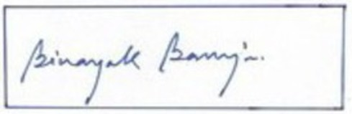

Signature of Candidate: (**Digital Signature**)

Name: BINAYAK BANERJEE

Date: 04-08-2024

1. **Executive summary and title**:

Title of the BDM project: **“Optimizing inventory management for improving resource mobilization, growth and profitability of a retail pharmaceutical business”**

The business data management project focuses on a local pharmaceutical shop ‘**New Medica**’ located in Rishra, a suburban locality in Serampore subdivision of Hooghly district ,West Bengal. The business is B2C and deals in the segment of pharmaceutical retail business.

The business lacks in technical expertise of handling inventory database management system leading to stockouts and overstocks, cash flow problem and shelf space management issues.

The issues will be addressed by segmentation of items into categories based on the business transaction data shared and further analyzing it to obtain capital blockage , overstocking and wastage in the form of expired medicines.

The expected outcome from the project would help ‘New Medica’ In achieving better inventory management by addressing the issues of capital blockage, proper monitoring of purchases to avoid overstocking and optimizing resource allocation to achieve sales growth and profitability.

2. **Organization background:**

New Medica is a leading pharmaceutical shop in Rishra, a suburban locality in Serampore subdivision of Hooghly district,West Bengal. It is a retail shop dealing in B2C buisness and catering to the needs of the people of this locality (population 1,74000 approximately).The business has made annual sales turnover of 78.3 Lakhs in the financial year 2022-2023. New Medica is a partnership family business established in the year 1972 as ‘Medica’ and has grown with the passage of time and renamed as ‘New Medica’ in the year 2006.In recent years New Medica has been facing stiff competition from branded establishments like ‘Apollo Pharmacy’ and ‘Frank Ross’ housed within a distance of 100 meters. These chain stores with huge storage facility and stock in hand are gradually eating away customer base of smaller retail shops like ‘New Medica’ in the Rishra locality. The competition is also compounded with the advent of online medical stores like ‘Sastasundar’,’1mg’etc. In this competitive environment New Medica is exploring ways to enhance customer base, better customer service, digitalization of business process and cost optimization by improving inventory management system.

**3. Problem Statement:**

A detailed discussion with the owner of New Medica has given the understanding that implementation of quality inventory management mechanism should be the focus area to address the issues of :

* Cash flow problem.
* Minimizing blockage of limited resource.
* Improving shelf space utilization in existing infrastructure.
* Minimizing wastage on account of expiry of medicinal items.

**4.Background of the problem:**

During discussion with owner and serving staff of New Medica it is understood that traditional business practice was disrupted with the introduction of Goods & Service Tax (GST) collection system by Government of India. Switching from Value Added Tax (VAT) system to GST system posed several challenges for this retail business, primarily in the areas of technological challenges, compliance and documentation, cash flow problem and inventory management. Creating infrastructure for digitized documentation of business transaction data entailed additional investment for hardware setup, allocating space for hardware installation within existing storage infrastructure, selection of suitable accounting software, hiring tax consultant and training staff for smooth operation.

Currently the business lacks in technical expertise of handling inventory database management system provided in the accounting software. They are adapted to the process of entering supplier’s challan to maintain purchase data and generating customer’s sales bill to maintain sales data on a regular basis. The monitoring of purchased stock, based on ‘Date of Expiry’ of individual item recorded in the challans, is not being done to track wastage and loss on account of medicine expiry. External problems also being faced with improper challans not in conformity with the GST format.

**5.Problem Solving Approach:**

The scope of addressing the problems of ‘New Medica’ is restricted to scrutinizing the inventory database of purchase and sales of medicines for the period from April 2023 to September 2023, shared for this project. In this exercise, focus is to be given for the following problem solving approaches:

1. Identification and segmentation of items into the following categories:

* Non-moving items: These items comprise medicines which were purchased or already in stock but no sales were made from the stock causing capital blockage and occupying storage space.
* Slow moving items: These items comprise medicines where there is no regularity of sales but average monthly purchase is greater than twice the average monthly sales causing the issue of over-stocking, resulting into capital blockage and occupying storage space.
* Running items: These items comprise medicines where there is regular monthly purchase caused by the regular demand. The criteria of segregating this category of items is that the average monthly purchase is greater than average monthly sales. Here also scope of capital blockage is checked.
* Fast-moving items: These items comprise medicines where there is regular monthly purchase caused by the regular demand. The criteria of segregating this category of items is that the average monthly purchase is equal to the average monthly sales. Proper monitoring of purchase for these items is looked into to avoid failure to serve customer requirement due to stock out.

1. Monitoring timely procurement of fast-moving items intended to avoid stockouts for customer satisfaction.
2. Evaluation of percentage wise capital blockage across the segregated item categories for relocation of resource for better cash flow and better shelf space utilization by minimizing over stocking.
3. Tracking shelf life of items intended in minimization of resource wastage in form of item expired medicines.

**6. Expected Timeline:**

A. Work Breakdown Structure:

Approach a real business and communicate with business owner

Further analysis if required and generate required data visualizations wherever suitable.

Proof of originality of the data collected along with authorization letter from the business.

Understand the type of business and the problems it is facing.

Find solutions of the business problems and interpretation of the results obtained.

Video recordings of conversation with business owner.

Find how the problem can be solved and what value it will generate to the business in doing so.

Provide recommendation to the business based on the findings.

Primary data collection, data validation and data cleaning.

Submit final report and make a power point presentation for it and prepare for viva.

Analysis of the data along with description of the methods involved in it backed up with data visualizations.

Provide a timeline for execution of subtasks to complete the project.

1. **Gannt Chart of the project:**

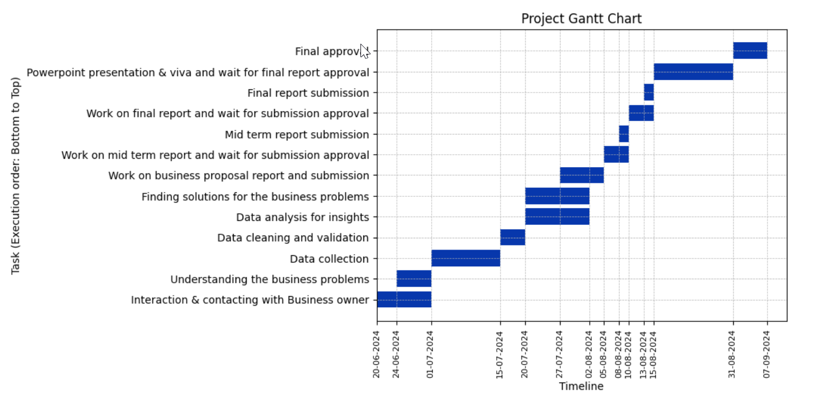

**7.Expected outcome:**

1. Generating lists of segmented categories viz. non-moving items, slow moving items and running items for proper monitoring of purchases to minimize capital blockage and optimization of shelf space.
2. Timely procurement of fast moving items to prevent stock outs and to ensure just-in-time inventory for optimum resource mobilization and customer satisfaction.
3. Identifying areas where resource can be reallocated for boosting sales and maintaining a regular cash flow.